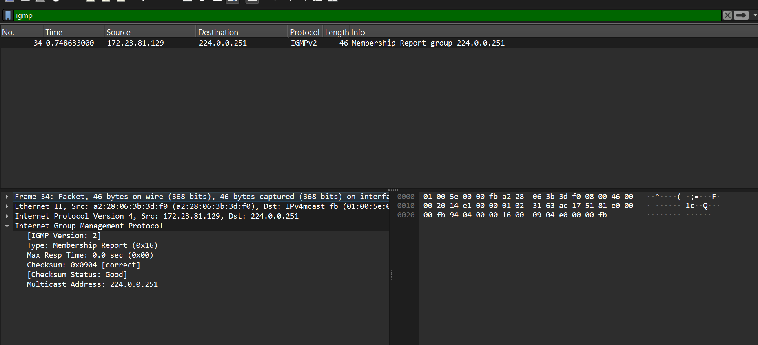| Field | Value |
| ----------------- | ---------------------------- |
| Protocol | **IGMPv2** |
| Type | **Membership Report (0x16)** |
| Source IP | **172.23.81.129** |
| Destination IP | **224.0.0.251** |
| Max Response Time | **0.0 sec** |
| Checksum | **0x0904 — Correct** |
| Multicast Address | **224.0.0.251** |
| Packet Length | **46 bytes** |

